**Practical 6**

**Aim:- IP Service Level Agreements and Remote SPAN in a Campus Environment.**

**Topology:-**

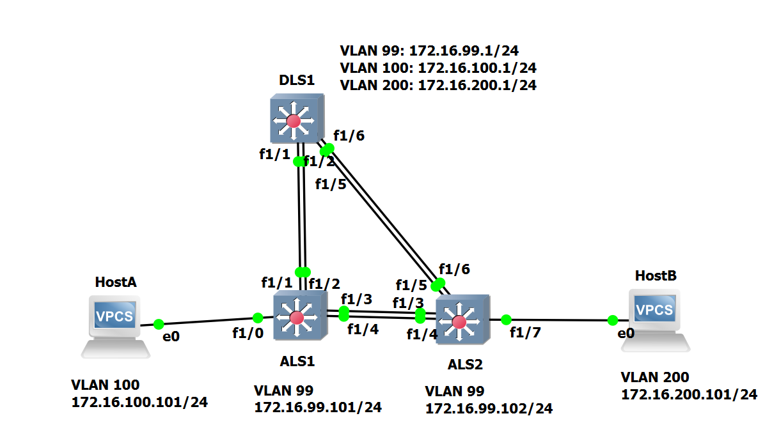

**Part 1: Prepare for the Lab**

**Step 1: Configure basic switch parameters.**

Configure an IP address on the management VLAN according to the diagram. VLAN 1 is the default management VLAN, but following best practice, we will use a different VLAN. In this case, VLAN 99.

Enter basic configuration commands on each switch according to the diagram.

**DSL1 Console:**

interface vlan 99

ip address 172.16.99.1 255.255.255.0

no shutdown

enable secret password

line vty 0 15

no login

privilege level 15

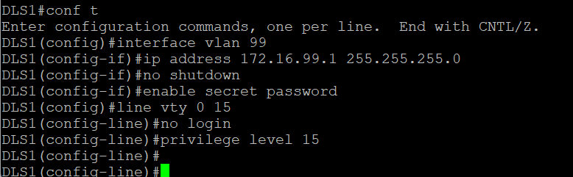

**ALS1 Console:**

interface vlan 99

ip address 172.16.99.1 255.255.255.0

no shutdown

exit

enable secret password

line vty 0 15

no login

privilege level 15

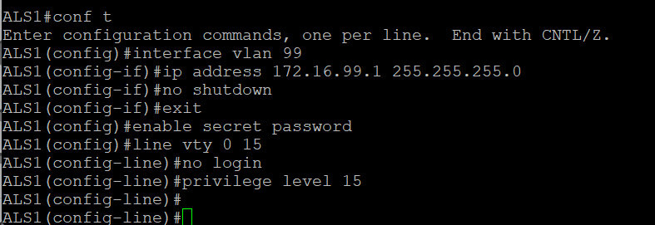

**ALS2 Console:**

interface vlan 99

ip address 172.16.99.1 255.255.255.0

no shutdown

exit

enable secret password

line vty 0 15

no login

privilege level 15

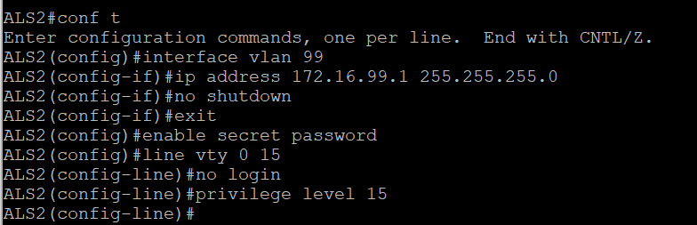

Configure default gateways on ALS1 and ALS2. These are access layer switches operating as Layer 2 devices and need a default gateway to send traffic from their management interface to other networks. Configure both ALS1 and ALS2.

**ALS1 Console:**

ip default-gateway 172.16.99.1



**ALS2 Console:**

ip default-gateway 172.16.99.1



**Step 2: Configure host PCs.**

Configure PCs Host A and Host B with the IP address and subnet mask shown in the topology. Host A is in VLAN 100 with a default gateway of 172.16.100.1. Host B is in VLAN 200 with a default gateway of 172.16.200.1.

**hostA Console:**

ip 172.16.100.101/24 172.16.100.1

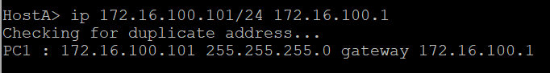

**hostB Console:**

ip 172.16.200.101/24 172.16.200.1

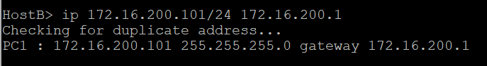

**Step 3: Configure trunks and EtherChannels between switches.**

Configure the trunks and EtherChannel from DLS1 to ALS1

**DLS1 Console:**

interface ran f 1/1 – 2

switchport trunk encapsulation dot1q

switchport mode trunk

channel-group 1 mode on

no shutdown

exit

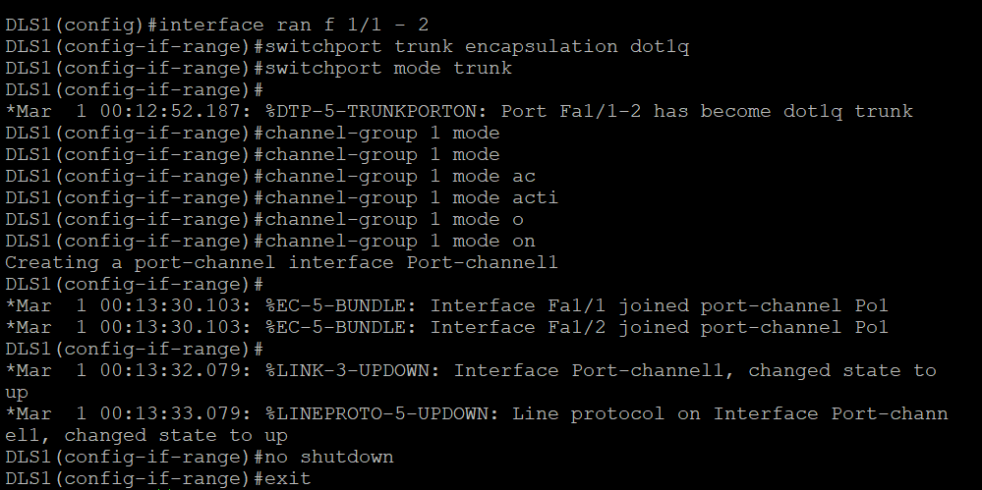

Configure the trunks and EtherChannel from DLS1 to ALS2

**DLS1 Console:**

interface ran f 1/5 – 6

switchport trunk encapsulation dot1q

switchport mode trunk

channel-group 2 mode on

no shutdown

exit

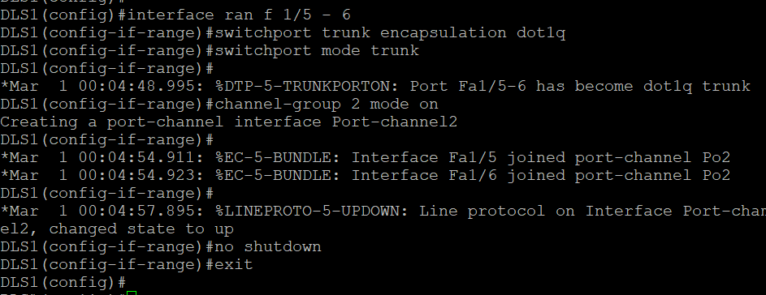

Configure the trunks and EtherChannel from ALS1 and DLS1

**ALS1 Console:**

interface range f 1/3 – 4

switchport mode trunk

channel-group 3 mode on

no shutdown

exit

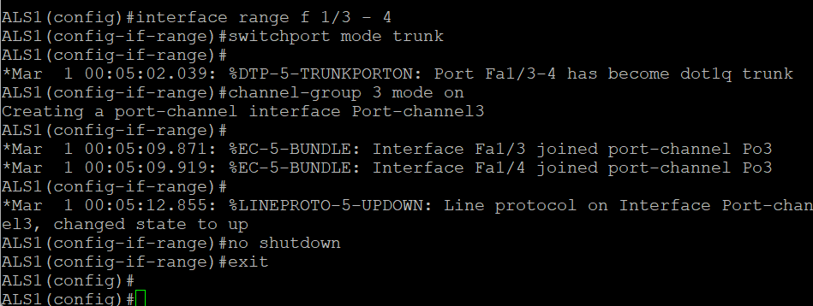

Configure the trunks and EtherChannel from ALS1 and ALS2

**ALS1 Console:**

interface range f 1/1 – 2

switchport mode trunk

channel-group 2 mode on

no shutdown

exit

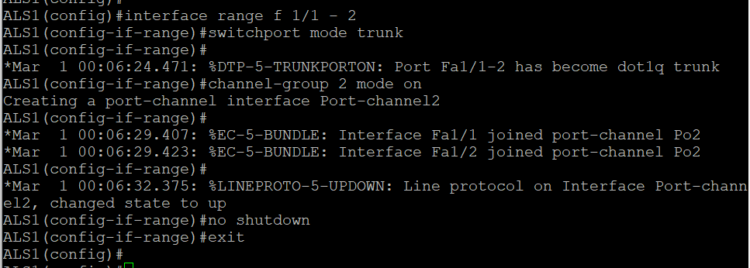

Configure the trunks and EtherChannel from ALS2 and DLS1

**ALS2 Console:**

interface range f 1/3 – 4

switchport mode trunk

channel-group 3 mode on

no shutdown

exit

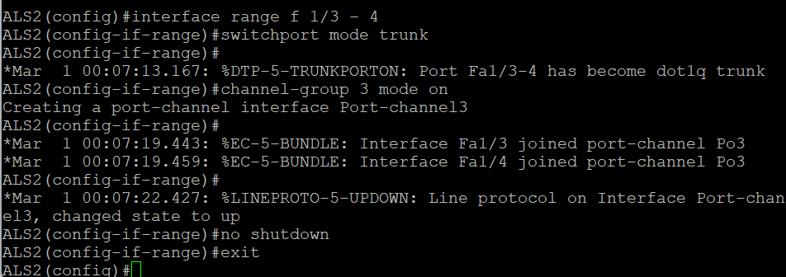

Configure the trunks and EtherChannel from ALS2 and ALS1

interface range f 1/5 – 6

switchport mode trunk

channel-group 2 mode on

no shutdown

exit

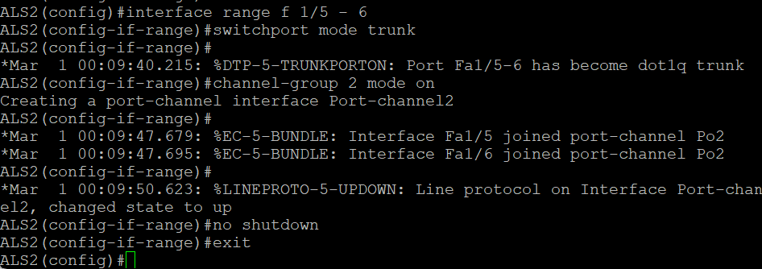

Step 4: Configure VTP on ALS1 and ALS2

**ALS1 Console:**

vtp mode client

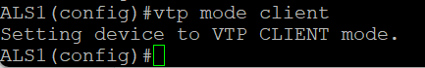

**ALS2 Console:**

vtp mode client

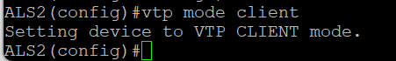

**Step 5 : Configure VTP on DLS1.**

Create the VTP domain on DLS1, and create VLANs 100 and 200 for the domain.

**DLS1 Console:**

vtp domain SWPOD

vtp version 2

vlan 99

name Management

vlan 100

name Finance

vlan 200

name Engineering

exit

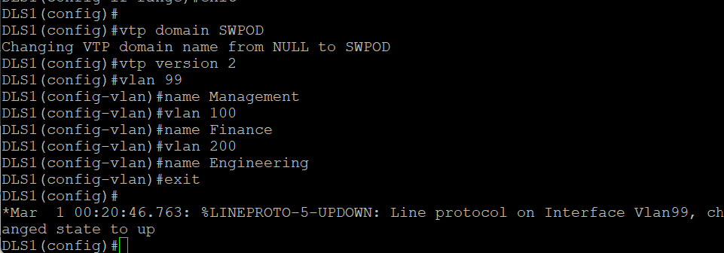

Step 6: Configure access ports.

**ALS1 Console:**

interface fastEthernet 1/0

switchport mode access

switchport access vlan 100

no shut

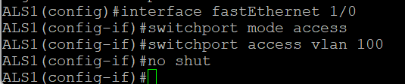

**ALS2 Console:**

interface fastEthernet 1/0

switchport mode access

switchport access vlan 200

no shut

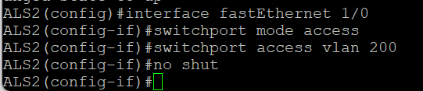

Step 7: Configure VLAN interfaces and enable routing

interface vlan 100

ip address 172.16.100.1 255.255.255.0

interface vlan 200

ip address 172.16.200.1 255.255.255.0

exit

ip routing

exit

show ip route

tclsh

foreach address {

172.16.99.1

172.16.99.101

172.16.99.102

172.16.100.1

172.16.200.1

172.16.100.101

172.16.200.101

} { ping $address }

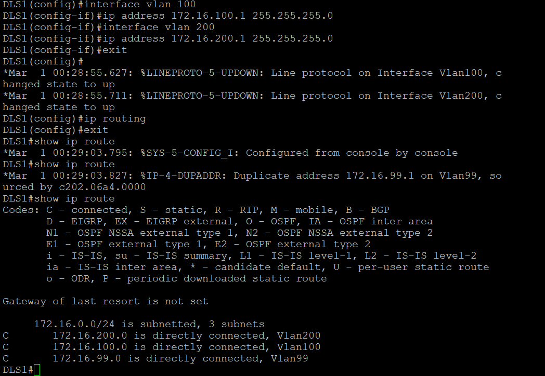

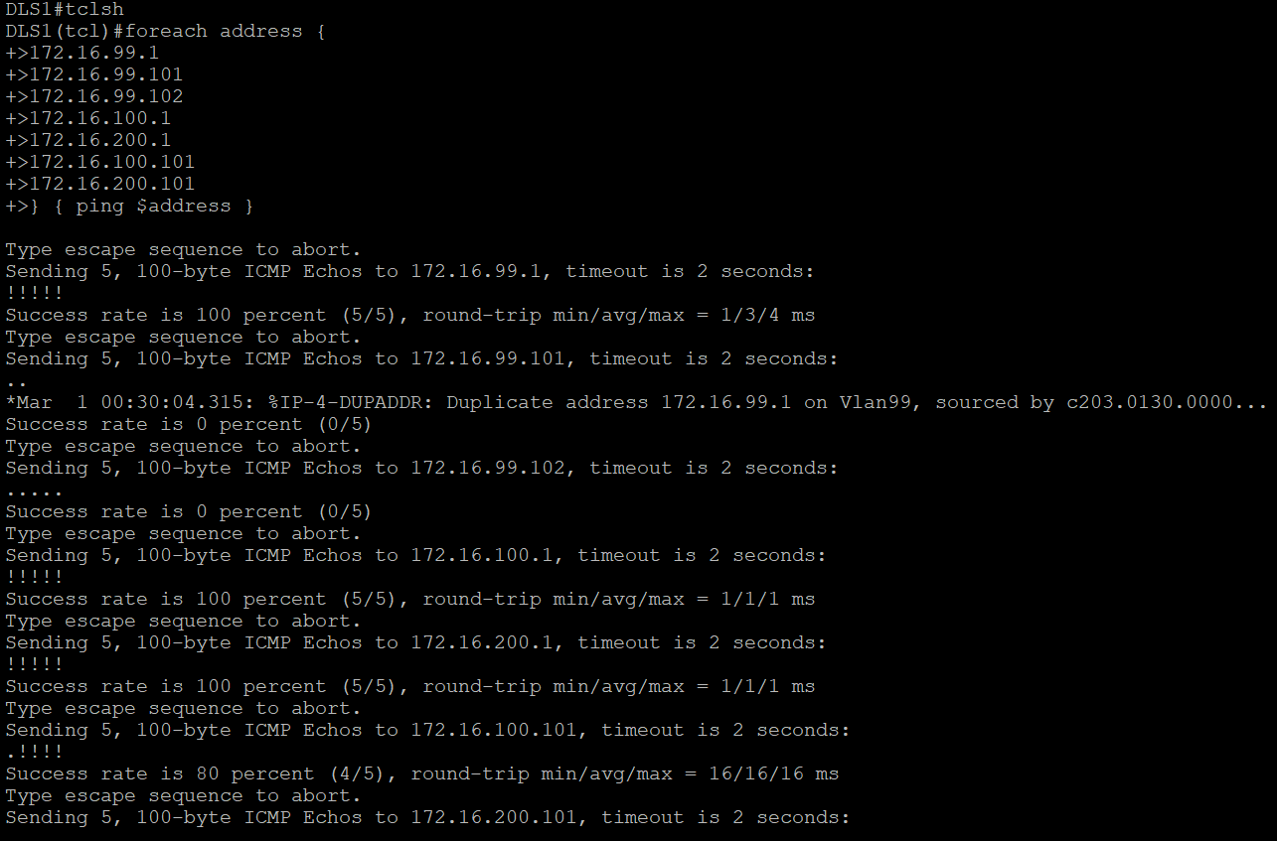

Part 2: Configure Cisco IOS IP SLA

Step 1: Configure Cisco IOS IP SLA responders

**ALS1 Console:**

exit

ip sla responder

ip sla responder udp-echo ipaddress 172.16.99.1 port 5000

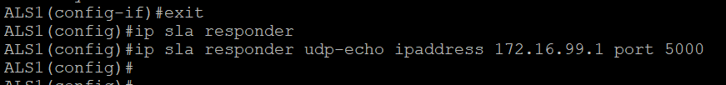

**ALS2 Console:**

exit

ip sla responder

ip sla responder udp-echo ipaddress 172.16.99.1 port 5000

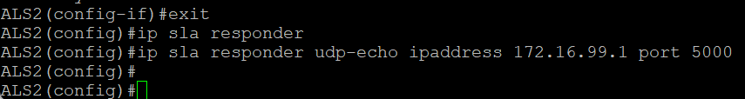

Step 2: Configure the Cisco IOS IP SLA source to measure network performance

DLS1 Console:

ip sla 1

icmp-echo 172.16.100.101

exit

ip sla 2

icmp-echo 172.16.200.101

exit

ip sla 3

udp-jitter 172.16.99.101 5000

exit

ip sla 4

udp-jitter 172.16.99.102 5000

exit

ip sla schedule 1 life forever start-time now

ip sla schedule 2 life forever start-time now

ip sla schedule 3 life forever start-time now

ip sla schedule 4 life forever start-time now

exit

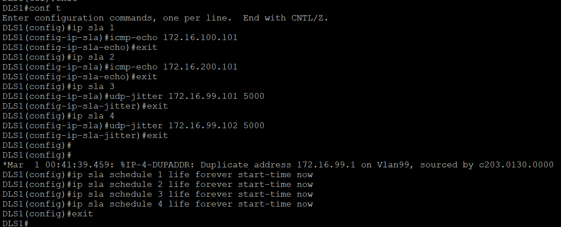

Step 3: Monitor IP SLAs operations

DLS1 Console:

show ip sla configuration 1

show ip sla configuration 3

show ip sla application

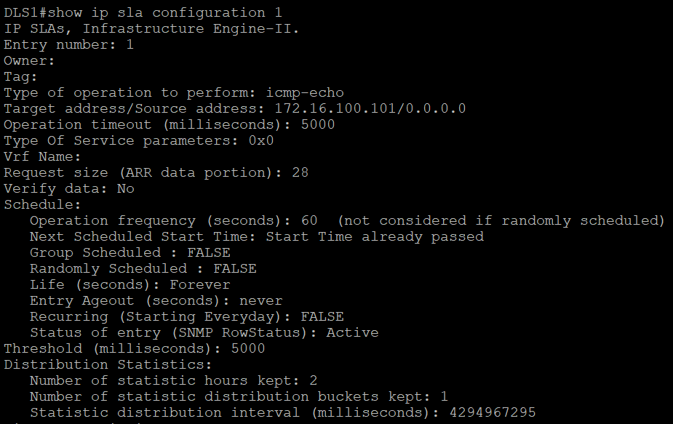

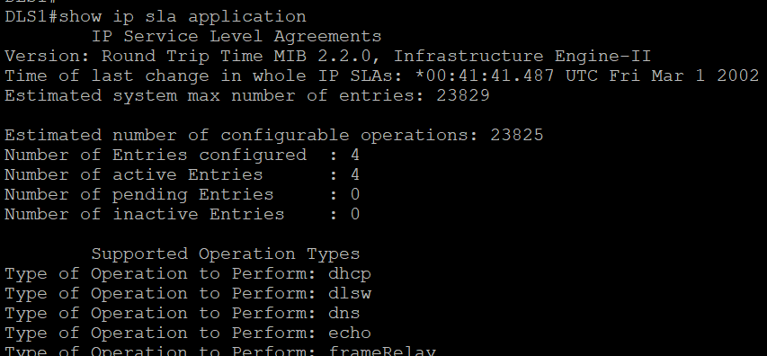

ALS1 Console:

show ip sla responder

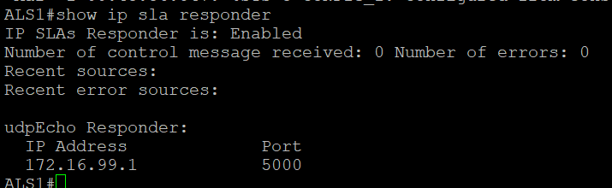

DLS1 Console:

show ip sla statistics 1

show ip sla statistics 3

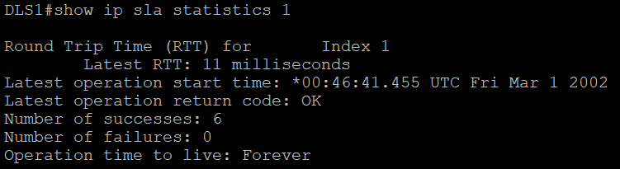

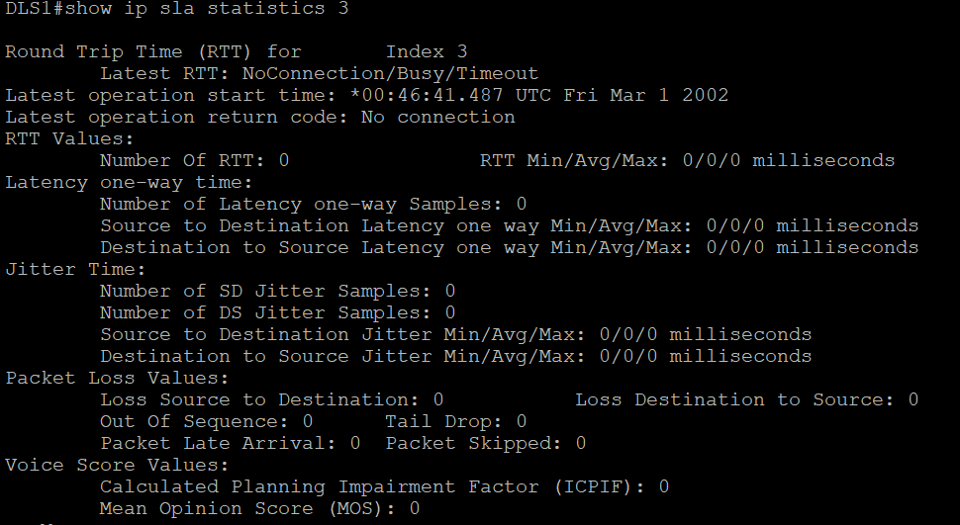

ALS1 Console:

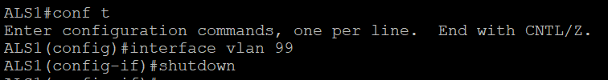

DSL1 Console:

